**Hands On Lab 3**

# **Spring Boot CRUD Example with Spring MVC – Spring Data JPA – ThymeLeaf - Hibernate - MySQL**

In this Spring Boot lab, you will learn develop a Java web application that manages information in a database – with standard CRUD operations: Create, Retrieve, Update and Delete. We use the following technologies:

* ****Spring Boot:**** enables rapid application development with sensible defaults to reduce boilerplate code. Spring Boot also helps us create a standalone, executable Java web application with ease.
* ****Spring MVC:**** simplifies coding the controller layer. No more boilerplate code of Java Servlet classes.
* ****Spring Data JPA:**** simplifies coding the data access layer. No more boilerplate code of DAO classes.
* ****Hibernate****: is used as an ORM framework – implementation of JPA. No more boilerplate JDBC code.
* ****ThymeLeaf****: simplifies coding the view layer. No more cluttered JSP and JSTL tags.
* And ****MySQL**** as the database.

For project development, we use STS 4 IDE, JDK 11 and Maven.

This is the basic procedure:

1. Create MySQL Database

2. Create Spring Boot Starter Maven Project in STS

3. Configure Data Source Properties

4. Code Domain Model Class

5. Code Repository Interface

6. Code Service Class

7. Code Spring MVC Controller Class

8. Code Spring Boot Application Class

9. Implement List Products Feature

10. Implement Create Product Feature

11. Implement Edit Product Feature

12. Implement Delete Product Feature

13. Test and package the Spring Boot CRUD Web Application

## **1. Create MySQL Database**

Suppose that our Spring Boot web application will manage product information in this table:

You can execute the following MySQL script to create the ****product**** table:

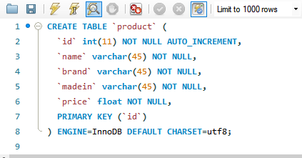

The table definition after cretion is below:

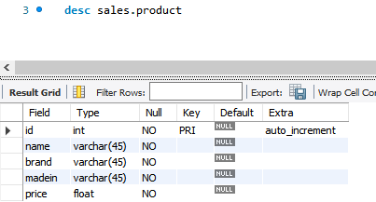

The name of the database schema is ****sales****.

## **2. Create Spring Boot Project**

Create a Spring Boot Starter project and specify only few dependencies: Spring Boot Starter Web, Spring Boot Data JPA, Spring Boot ThymeLeaf and MySQL JDBC driver.

## 

## **3. Configure Data Source Properties**

Add the following content: to the ****application.properties****file under the ****src/main/resources****directory .

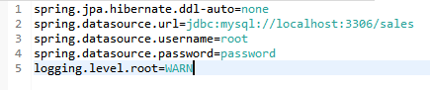

Change the credentials and/or logging as per your preferences.

The first line tells Hibernate to make no changes to the database. And we specify the database connection properties in the next 3 lines (change the values according to your settings). And the last line we set the logging level to WARN to avoid too verbose output in the console.

## **4. Code Domain Model Class**

Create the domain model class ****Product****to map with the ****product**** table in the database as follows:

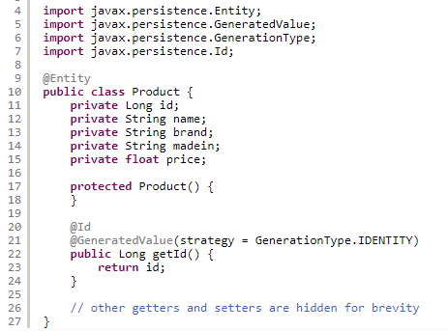

This is a simple JPA entity class with the class name and field names are identical to column names of the table ****product**** in the database, to minimize the annotations used.

## 

## **5. Code Repository Interface**

Next, create the ****ProductRepository****interface as simple as follows:

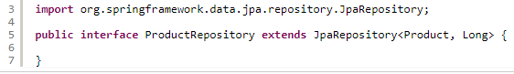

As you can see, this interface extends the JpaRepository interface from [Spring Data JPA](https://www.codejava.net/frameworks/spring/understand-spring-data-jpa-with-simple-example" \t "https://www.codejava.net/frameworks/spring-boot/_blank). JpaRepository defines standard CRUD methods, plus JPA-specific operations. We don’t have to write implementation code because Spring Data JPA will generate necessary code at runtime, in form of proxy instances.

So the purpose of writing the repository interface is to tell Spring Data JPA about the domain type (Product) and ID type (Long) to work with.

## **6. Code Service Class**

Next, we need to code the ****ProductService****class in the service/business layer with the following code:

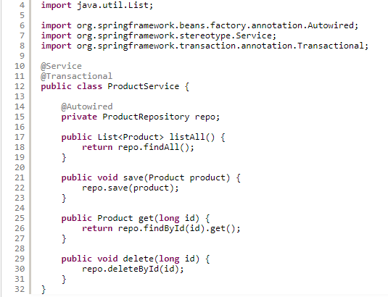

In this class, we inject an instance of ProductRepository via private field using @Autowired annotation. At runtime, Spring Data JPA will generate a proxy instance of ProductRepository and inject it to the instance of ProductService class.

You might see this service class is redundant as it delegates all the calls to ProductRepository. In fact, the business logic would be more complex over time, e.g. calling two or more repository instances.

So we create this class for the purpose of extensibility in future.

## **7. Code Spring MVC Controller Class**

Next, create the ****AppController****class acts as a Spring MVC controller to handle requests from the clients – with the initial code as follows:

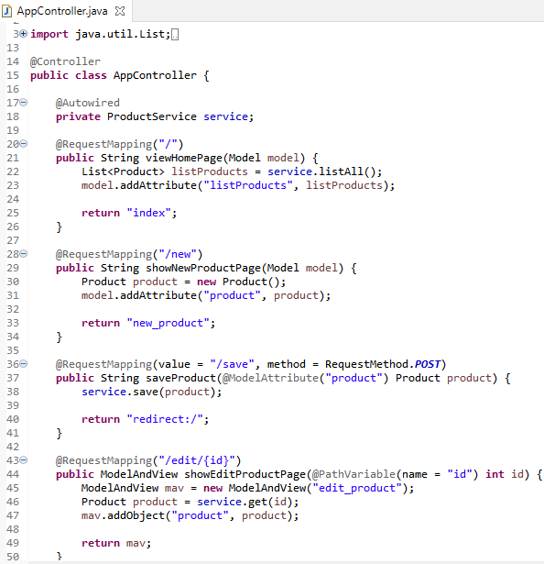

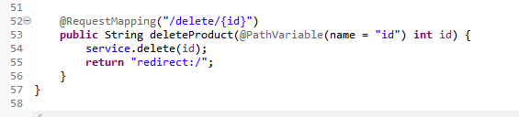

As you can see, we inject an instance of the ProductService class to this controller – Spring will automatically create one at runtime. We will write code for the handler methods when implementing each CRUD operation.

## **8. Code Spring Boot Application Class**

Next, check the class with main() method to bootstrap our Spring Boot application:

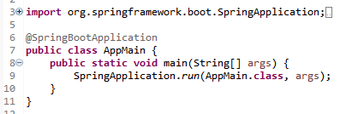

Here, the @SpringBootApplication annotation does all the magic stuffs such as create the web server instance and Spring MVC dispatcher servlet.

## **9. Implement List Products Feature**

The website’s home page displays a list of all products, so we have the following handler method in the Spring MVC controller class:

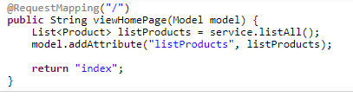

We use ThymeLeaf instead of JSP, so create the templates directory under src/main/resources to store template files (HTML).

Create the index.html file under src/main/resources/templates with the following code:

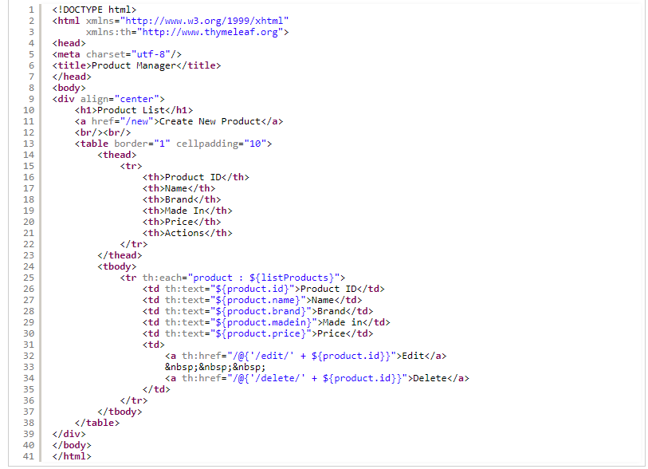

Now we can run the AppMain class to test our Spring Boot web application. You should see the Spring Boot logo appear in the Console view of Eclipse:

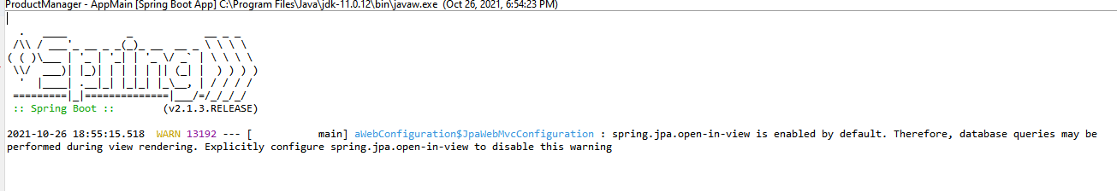

Open your web browser and type the URL http://localhost:8080 to see the website’s homepage:

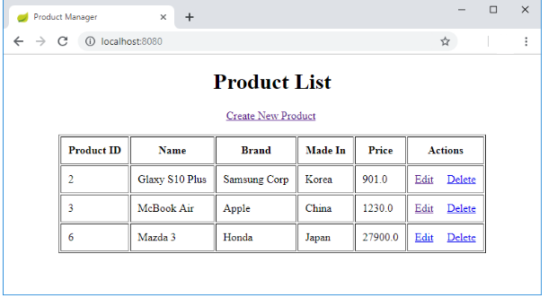

You see, the list of products gets displayed nicely – Suppose that you inserted some rows in the ****product**** table before.

## **10. Implement Create Product Feature**

You can see in the index.html, we have a hyperlink that allows the user to create a new product:



The relative URL new is handled by the following method in the AppController class:

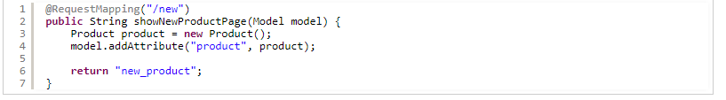

For the view, create the new_product.html file with the following code:

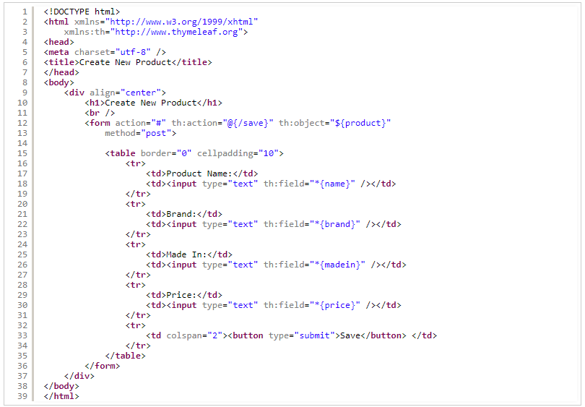

As you can see, here we use ThymeLeaf syntax for the form instead of Spring form tags. The Create New Product page looks like this:

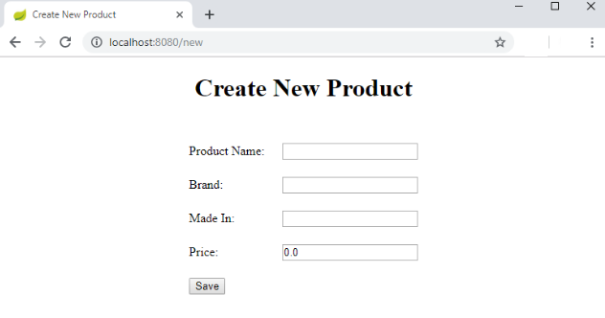

And we need to code another handler method to save the product information into the database:

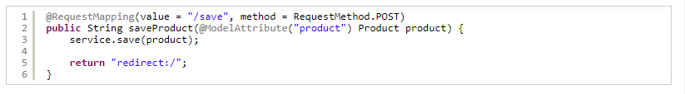

After the product is inserted into the database, it redirects to the homepage to refresh the product list.

## **11. Implement Edit Product Feature**

In the home page, you can see there’s a hyperlink that allows the users to edit a product:



Code the handler method in the controller class as follows:

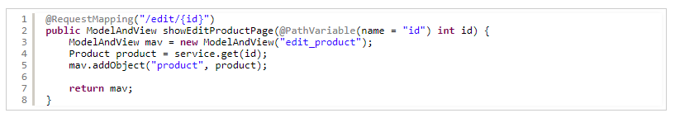

And code the view page edit_product.html with the following code:

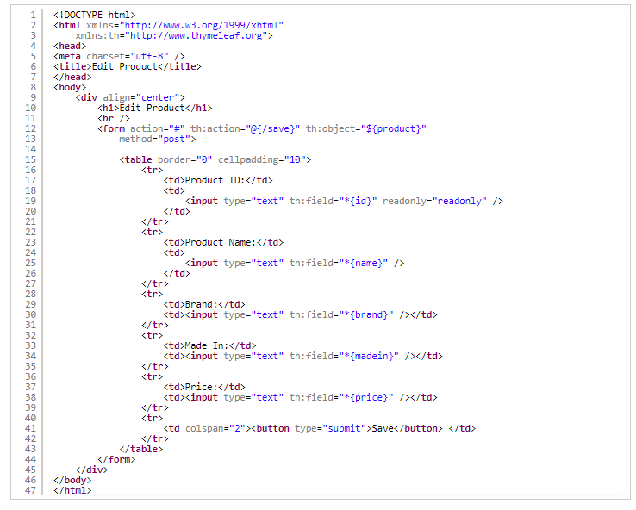

The edit product page should look like this:

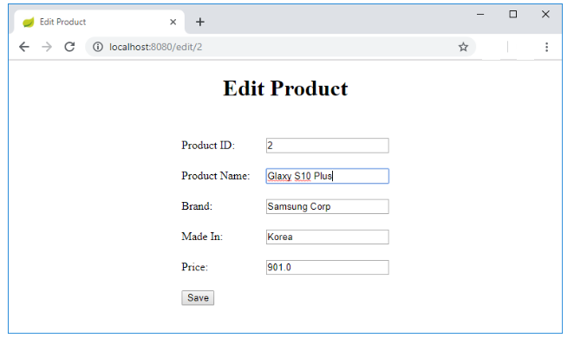

Click the Save button will update the product information into the database. The handler method saveProduct() is reused in this case.

## **12. Implement Delete Product Feature**

You can see the hyperlink to delete a product in the home page:



So code the handler method in the controller class as follows:

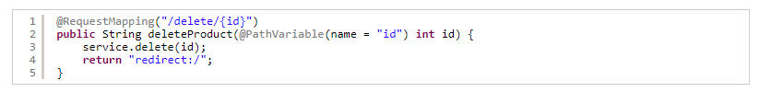

When the user clicks the Delete hyperlink, the corresponding product information is removed from the database, and the home page gets refreshed.

## **13. Test and package the Spring Boot CRUD Web Application**

To test the Spring Boot web application we have developed in Eclipse, run the AppMain class as Java Application.

To package the web application as an execute JAR file in Eclipse, right-click on the project, and select ****Run As > Maven build…**** then enter package as the goal name, and click ****Run****. If the build succeeded, you will see a JAR file is generated under the project’s target directory, with the name like ProductManager-0.0.1-SNAPSHOT.jar.

Now you can use the java command to run this JAR file:

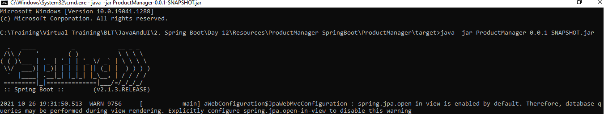

Navigate to <http://localhost:8080/> to test if the application deployed successfully.

For your reference, here’s the screenshot of the project structure:

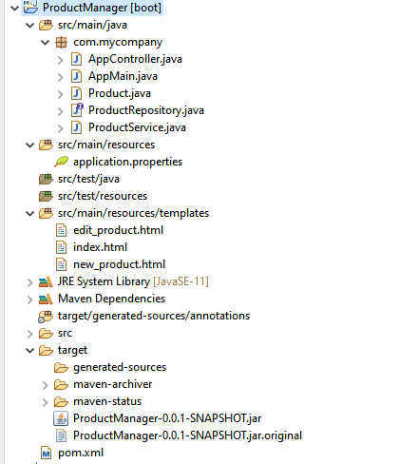

Great!! That’s how to develop an end-to-end Spring Boot CRUD application with Spring MVC, Spring Data JPA, ThymeLeaf, Hibernate and MySQL.

***************************************************************************************************